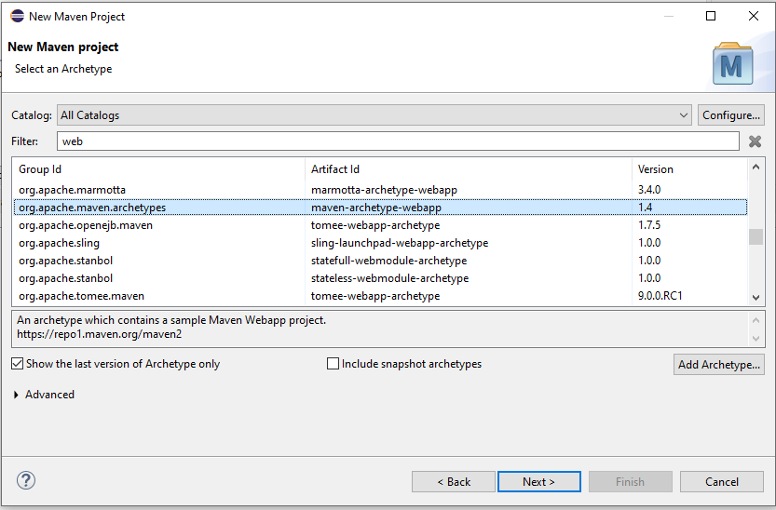

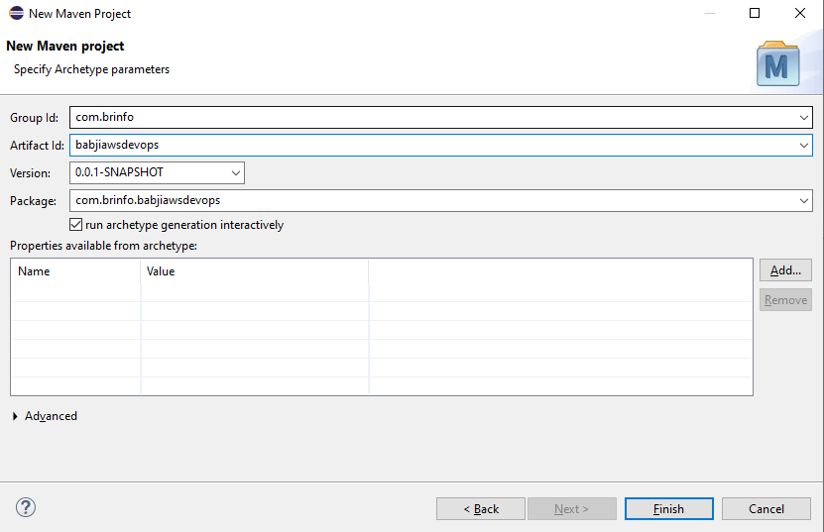

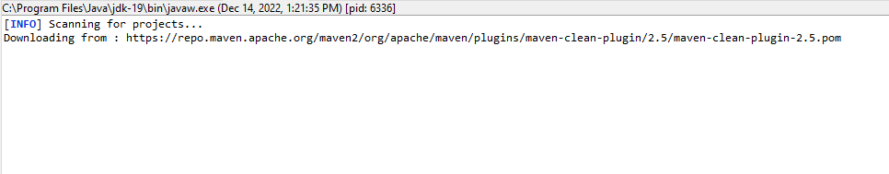

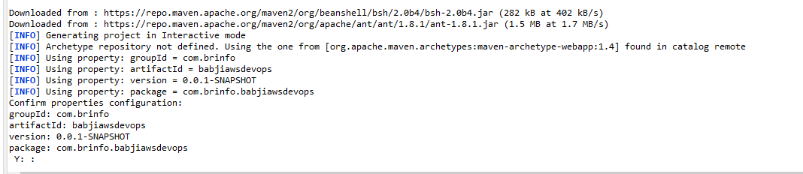

Y

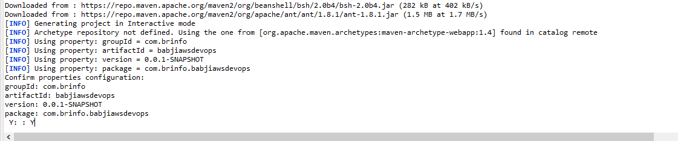

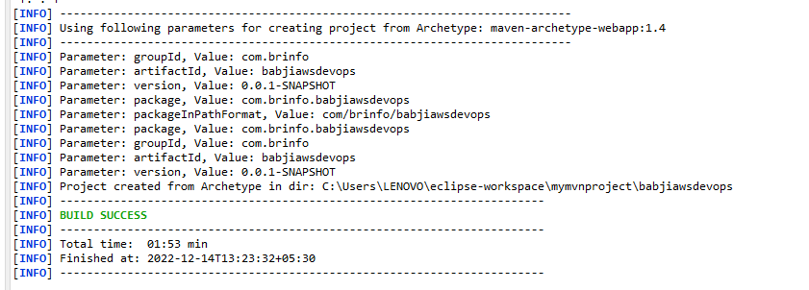

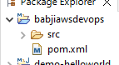

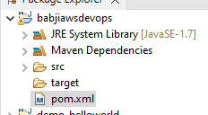

Add Dependancy & plgins

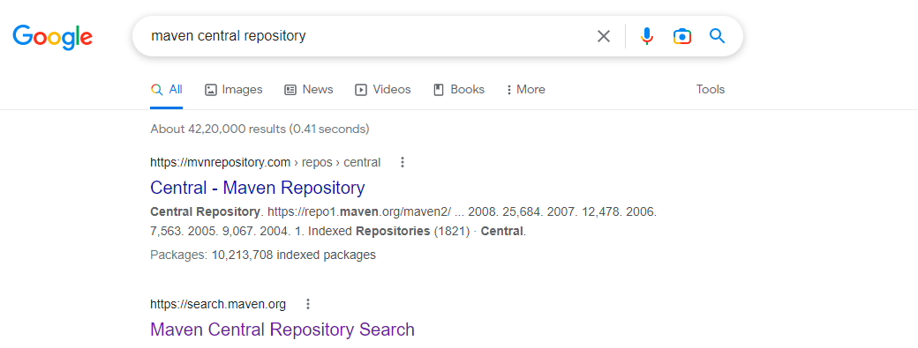

Search Reqieed Depedancy & Plugin

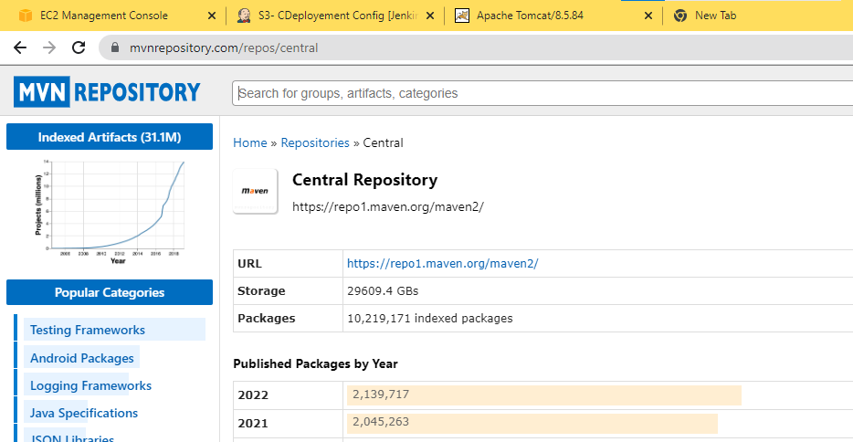

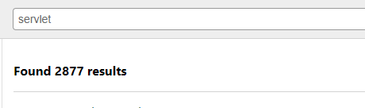

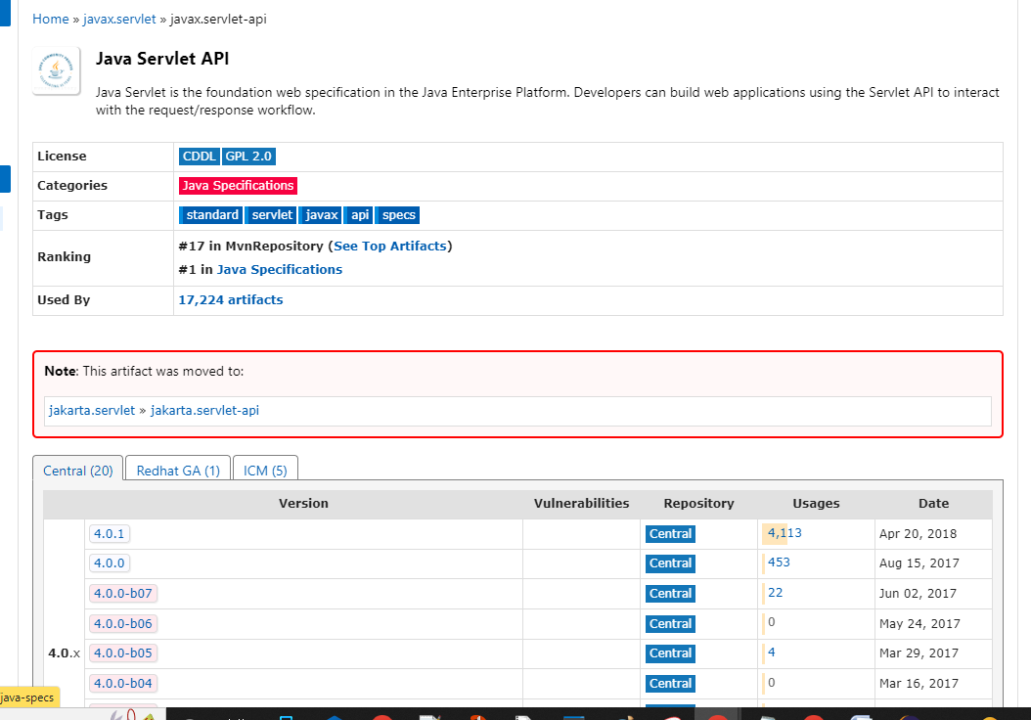

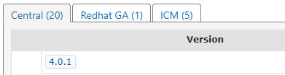

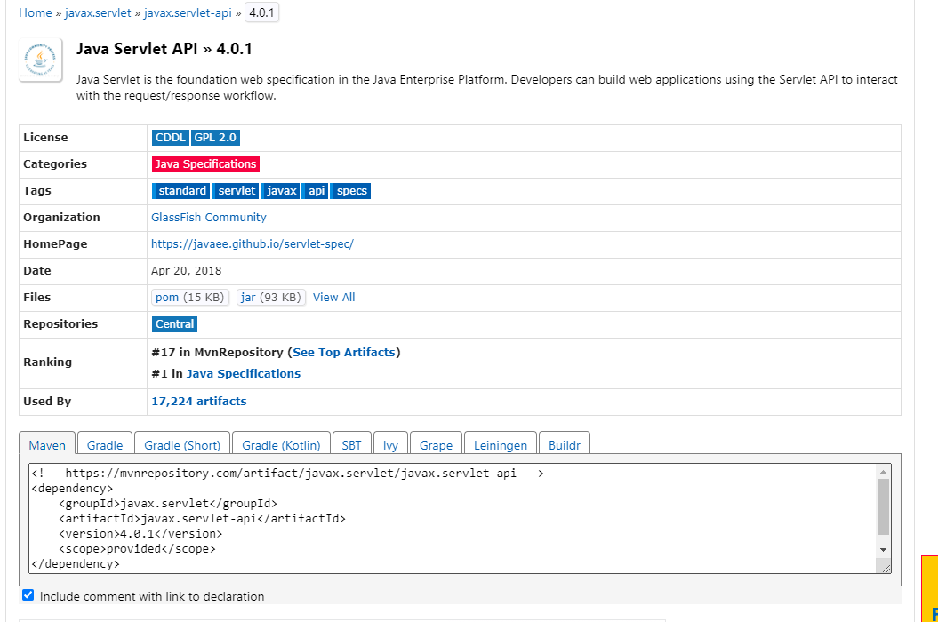

<!-- https://mvnrepository.com/artifact/javax.servlet/javax.servlet-api -->

<dependency>

<groupId>javax.servlet</groupId>

<artifactId>javax.servlet-api</artifactId>

<version>4.0.1</version>

<scope>provided</scope>

</dependency>

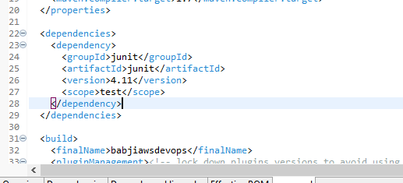

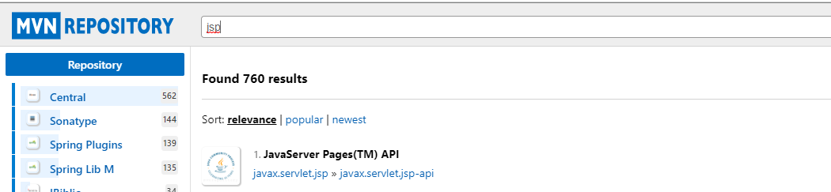

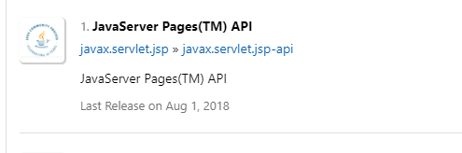

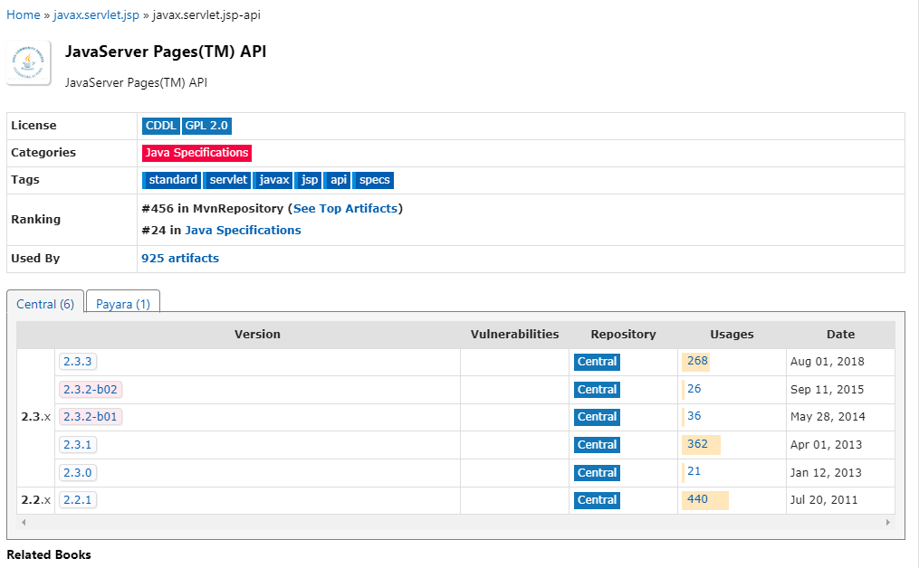





<!-- https://mvnrepository.com/artifact/javax.servlet.jsp/javax.servlet.jsp-api -->

<dependency>

<groupId>javax.servlet.jsp</groupId>

<artifactId>javax.servlet.jsp-api</artifactId>

<version>2.3.1</version>

<scope>provided</scope>

</dependency>

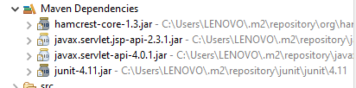

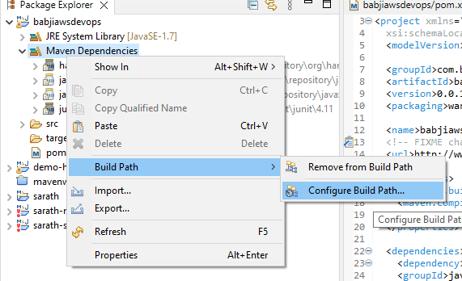

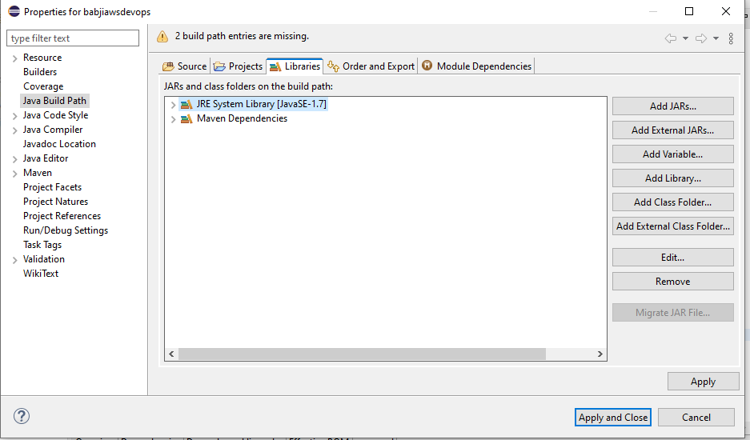

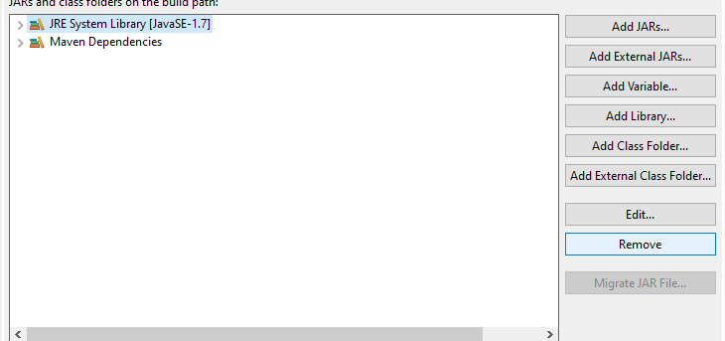

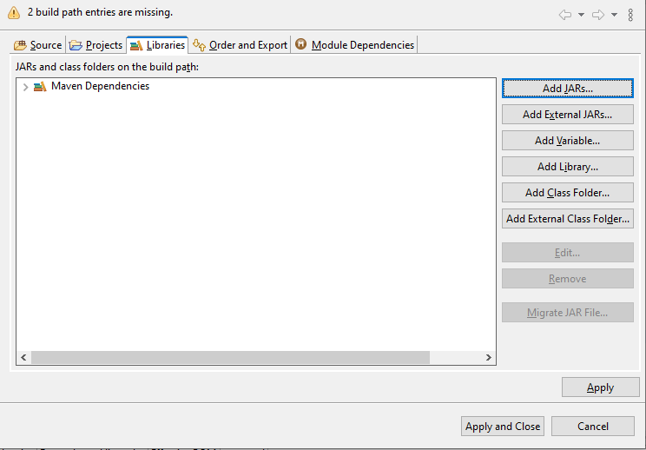



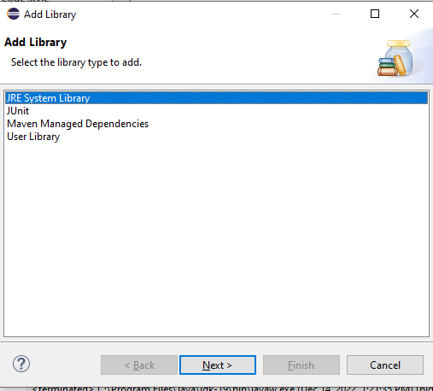

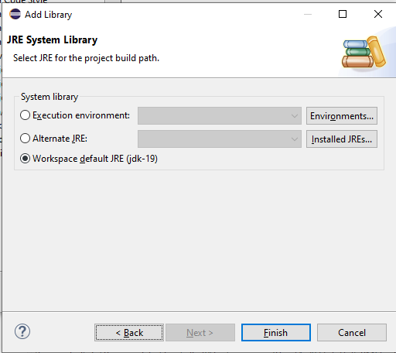

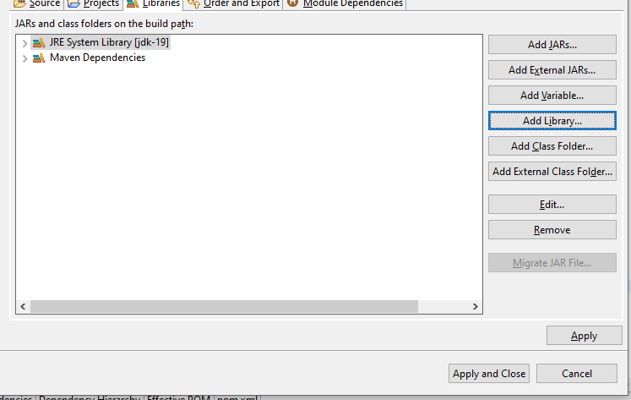

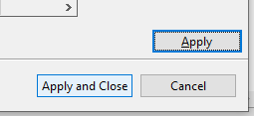

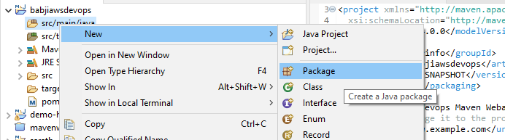

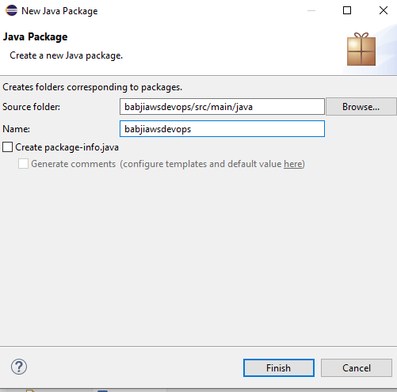

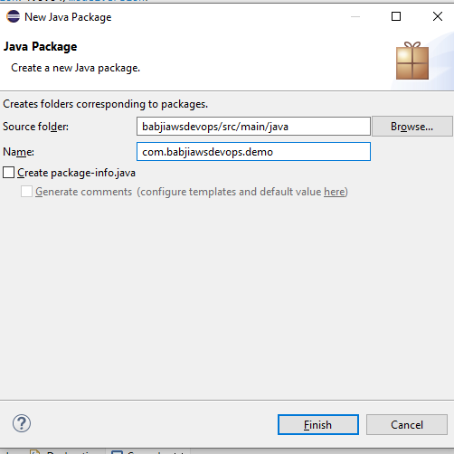

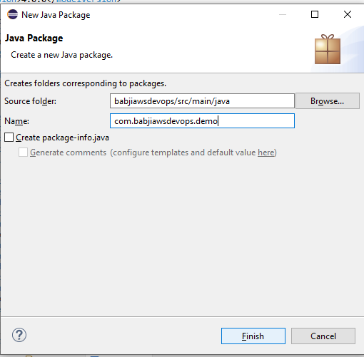

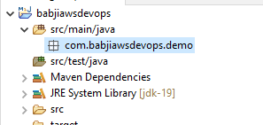

Create Servelet class

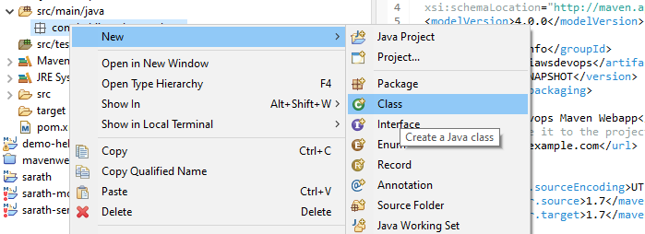

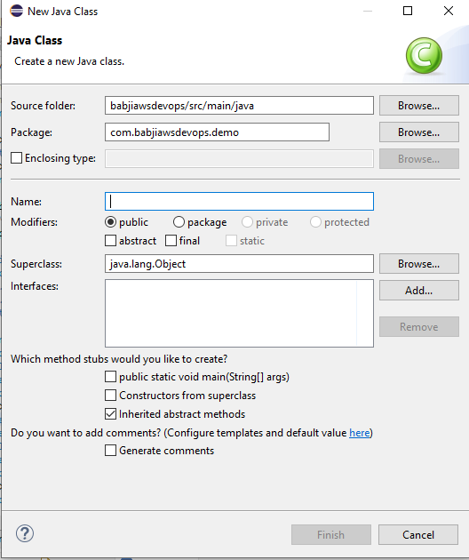

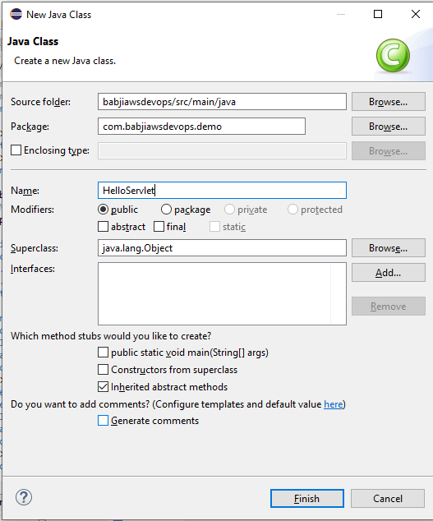

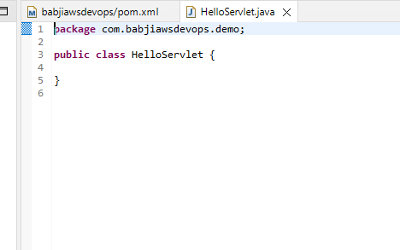

Write Code

// importing the javax.servlet package

// importing java.io package for PrintWriter

import javax.servlet.\*;

import java.io.\*;

// now creating a servlet by implementing Servlet interface

public class LifeCycleServlet implements Servlet {

ServletConfig config = null;

// init method

public void init(ServletConfig sc)

{

config = sc;

System.out.println("in init");

}

// service method

public void service(ServletRequest req, ServletResponse res)

throws ServletException, IOException

{

res.setContenttype("text/html");

PrintWriter pw = res.getWriter();

pw.println("<h2>hello from life cycle servlet</h2>");

System.out.println("in service");

}

// destroy method

public void destroy()

{

System.out.println("in destroy");

}

public String getServletInfo()

{

return "LifeCycleServlet";

}

public ServletConfig getServletConfig()

{

return config; // getServletConfig

}

}

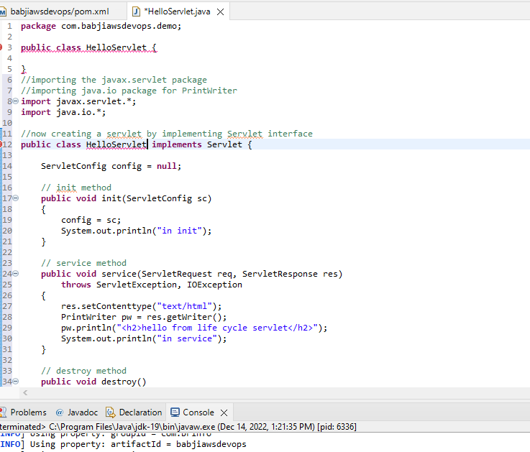

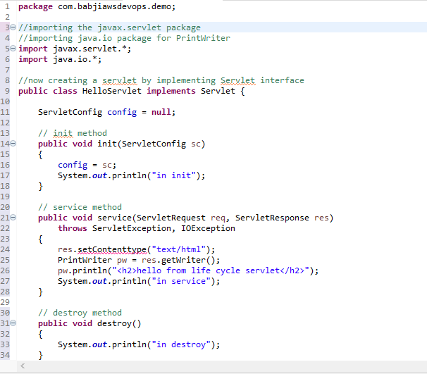

res.setContentType("text/html");

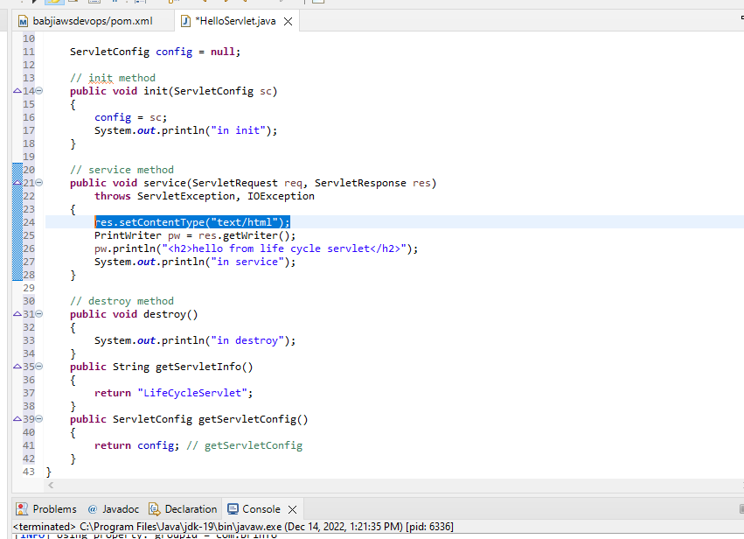

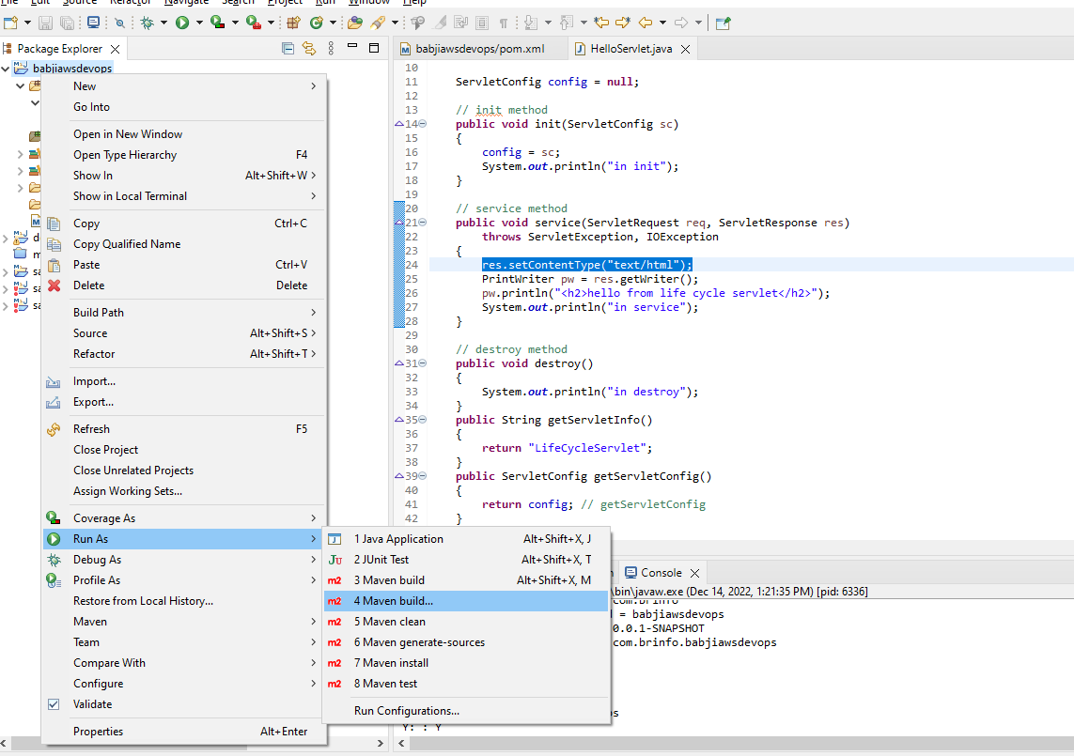

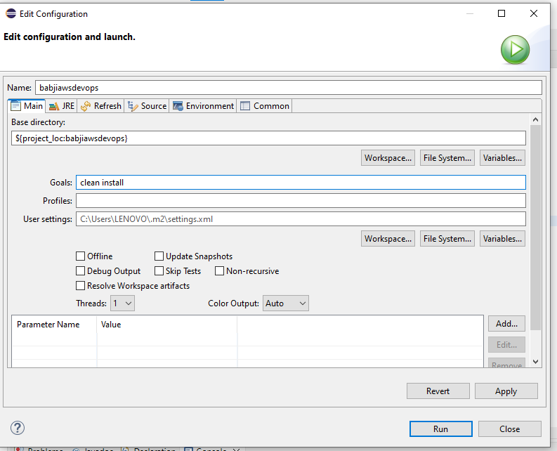

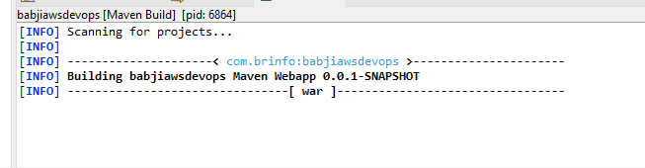

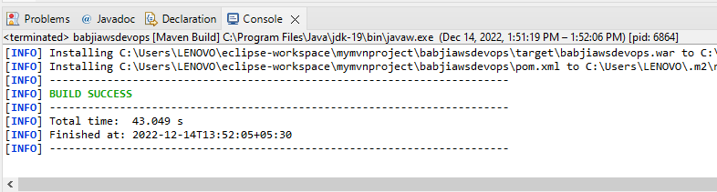

.war file generated

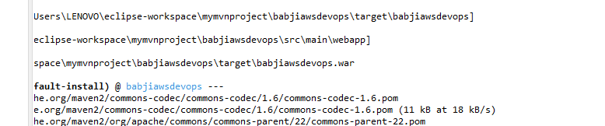

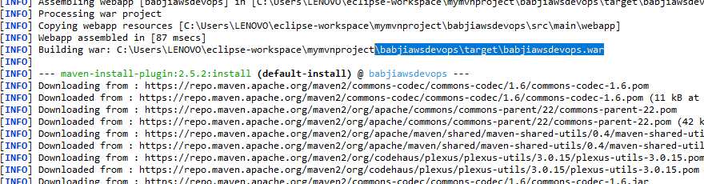

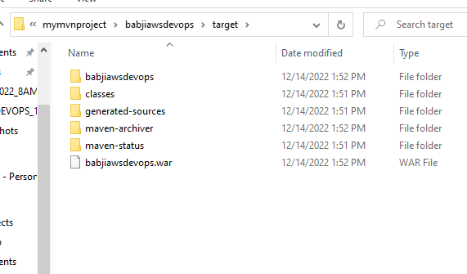

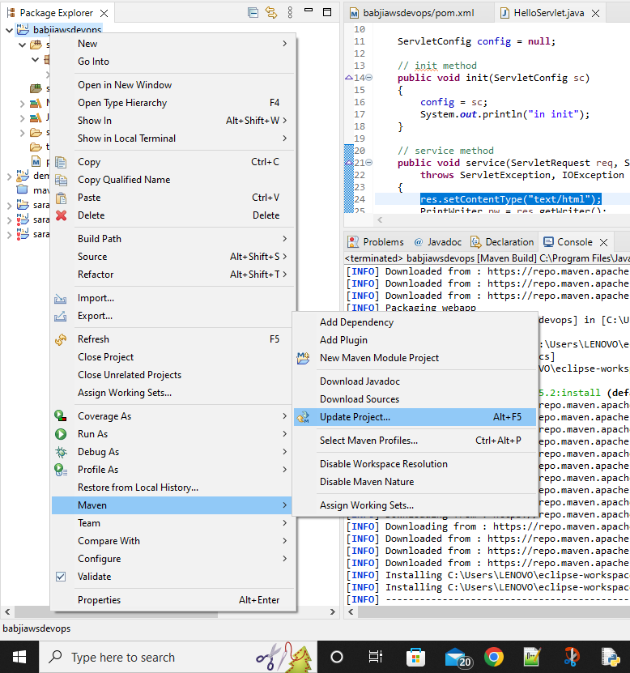

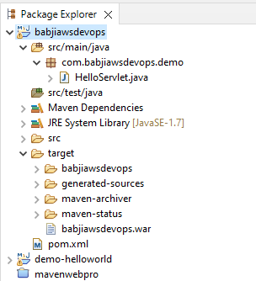

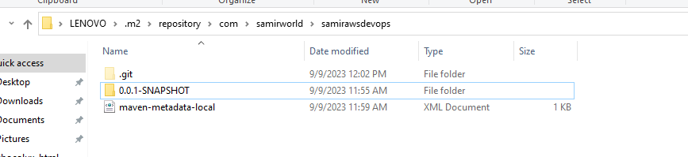

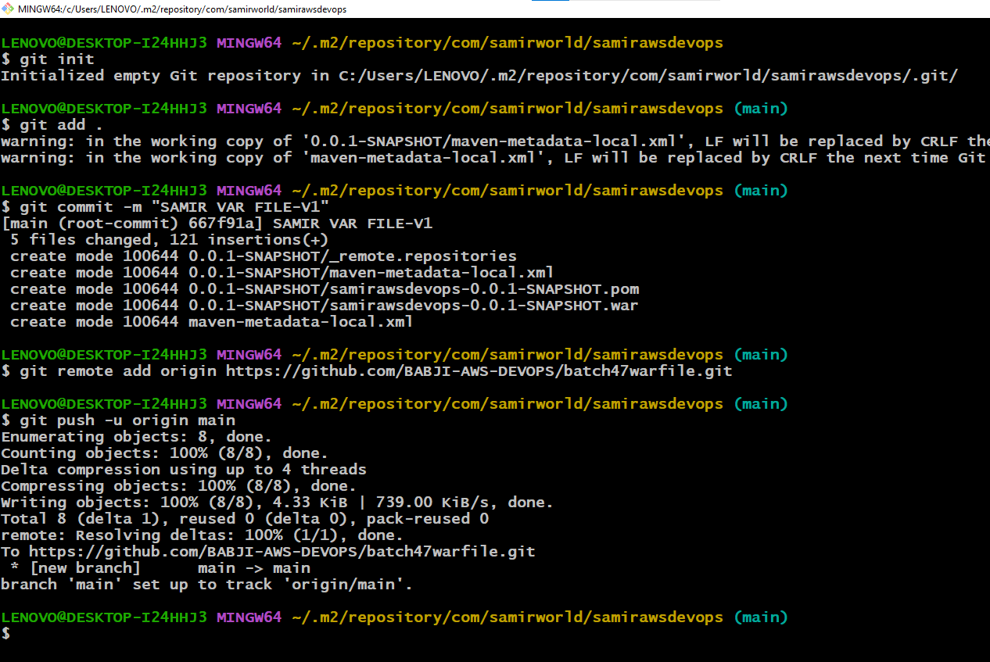

Create remote repo – batch47

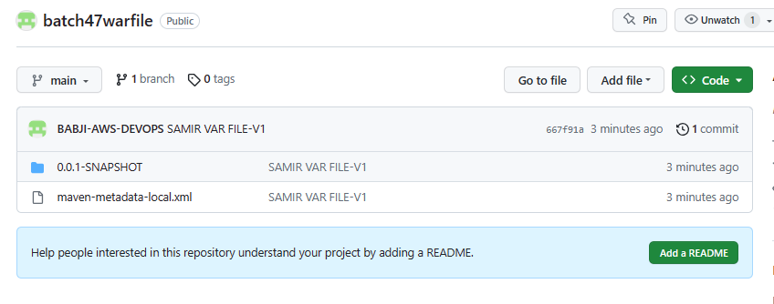

<https://github.com/BABJI-AWS-DEVOPS/batch47warfile.git>